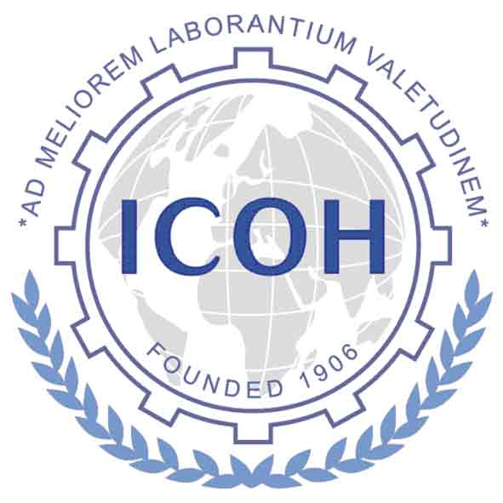
2024-2027 Triennium Timetable of Deliverables
from Scientific Committees

Below is the tentative schedule of dates for the deliverables of the Scientific Committees. The dates relate to the Midterm Meeting of Officers, Board, and Scientific Committee Chairs, tentatively scheduled for November 2025, with exact date and location to be determined; and to the ICOH 2027 Congress, which will be held in Mumbai, India, from 14 to 19 February 2027.

Online forms will be provided for each of the SC deliverables in the SC Virtual Office on the ICOH website www.icohweb.org. You need to use your password for access to the Virtual Office.

Due dates for Deliverables:

By end of  September 2024 | Appointment Process  - submission of the Transparency Declaration Form from SC Chair and Secretary  - Payment of membership fees for the triennium 2024-2027
By end of September 2024 | Report of Business Meeting associated with the ICOH2024 Congress (held virtually pre- or post-congress)
By end of  November 2024 | Scientific Committee Work Plan 2024-2027 to include:  - Planned work of the SC  - List of Members of the Scientific Committees
March – May 2025 | ICOH2027 Scientific Committee recommendations:  (Dates will depend on the Indian Organizers’ schedule)  - Scientific topics and speakers (for plenary and semi-plenary presentations)  - SC Special Session reservation  - Reviewers for Abstracts of Free Paper Topics
September 15, 2025 | SC Triennium Midterm Report – deadline for submission to VP
November 15, 2026 | SC Triennium Final Report – deadline for submission to VP
November 15, 2026 | ICOH2027 Scientific Committee Business Meeting Reservation
As needed | Notes from SC Business Committee Meetings
As needed | SC Sponsorship Funding Request (mainly for ICOH members from LMICs to attend SC events in virtual or in-presence formats)

